Chapter1 What is a computer

What is a computer?

* A computer is an electronic machine that performs operations and a set of operations is a program.
* A hardware is a physical part of computer.

Desktop laptop

* Case Screen
* Keyboard key board
* Mouse touch pad
* Screen

1. A power button use when we want to turn on computer.
2. Lock screen (Window + L)
3. Login screen Ctrl +Alt + Delete +log

Change Your Password

* Enter the magic keys Ctrl +Alt + Delete
* Select change a password

Change password

A Mouse Can Perform 5 Actions

* Action Usage
* Left Select objects
* Right click Open pop-up menus
* Double(left)click Open file, application
* Drag Move the select object
* Scroll Scroll on a document

S2 Work on Windows

1. What is an operating system?

* An operating system is a program that allow to intect with your computer.

1. When was the first window Operating system created?

* The first window operating system created in 1985.

1. Now which version of window are we using?

* Now we are using window 10.
* How to use window desktop?

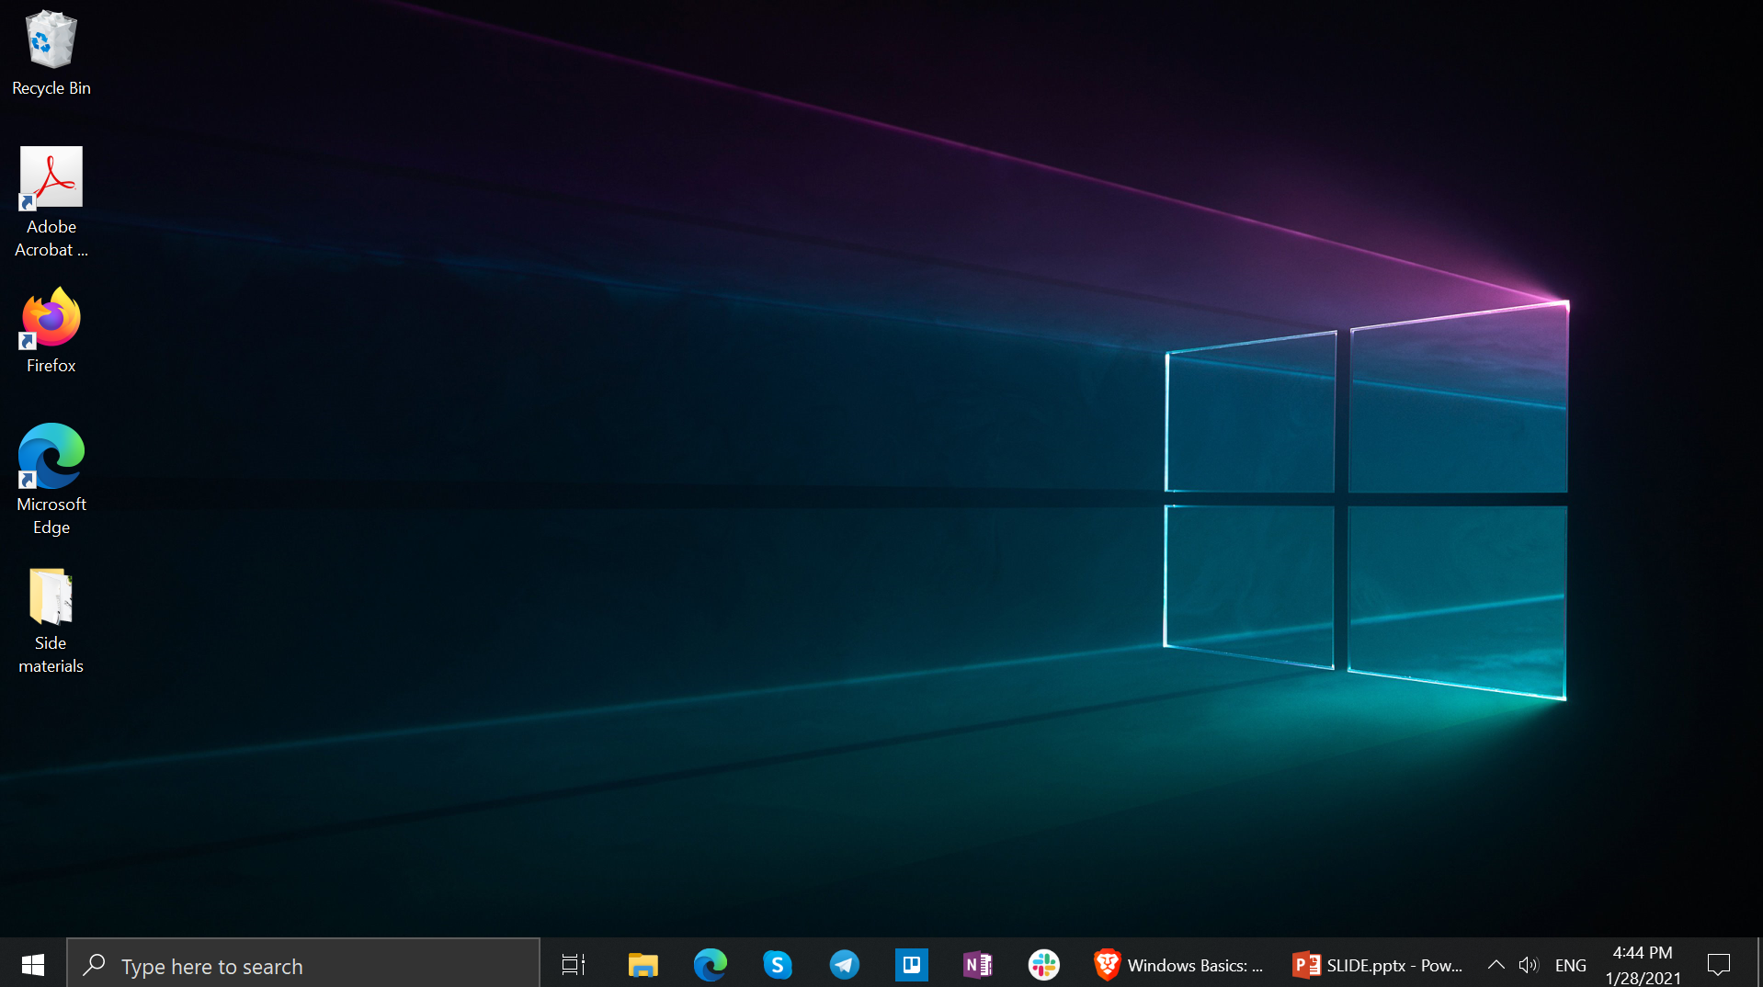

Start Menu

Recycle Bin

Application Icons

Taskbar

Desktop Background

Folder on desktop

***The Desktop***

* How to use window start menu and taskbar?
* On the canter or left of the taskbar, select the start icons.
* Press the window logo key on your keyboard.
* Swipe up from the button center or left of your screen.
* What is an **application**?
* An application is a software that allows you to **complete tasks**on your computer

Chapter2 S1 Files and Folders

* What is the purpose of each element here?
* A file
* A folder
* The enter key
* Hard drive
* What is a file?
* A file is a set of data representing a specific type of information. A file has name *an extension*, *a size*. the file extension can tell you what is the file type. A file size is the measure of space a file takes up on a storages medium such as a computer hard drive.
* What is the folder?
* A folder is container of file. A folder also container other folders.

File location

Files and folders are started in the hard drive of your computer.

* Hard drive in windows are represented with a letter (C or D).

File manipulation

Copy file (C or D)

Paste file (Ctrl V)

Delete file (Ctrl D)

Chapter3 S1 Network and Internet

What is Internet?

Internet is a network of computer spans the whole world.

What is a website, a web pages?

Website is a collection of web pages and related content that is identified by a common domain name and published on at least one web server. A web pages is a single document which contain text, images, video, audio….

What is a Web Browser?

A web browser is an application for accessing website contain information about the location of the web pages.

What is a Web Address?

A web address refers to the name that points to a locations where the website is hosted over the internet. It is also as the ***URL (Uniform resource Locator).***

* WHAT IS …?
* Firefox is a free open-source web browser developed by Mozilla.
* Chrome is cross platform web browser developed by Google.
* Www is an information system enabling documents and other web resource to be accessed over the Internet.
* YouTube is a global online video sharing and social media platform headquartered in San Bruno.

Network VS Internet

Network: a computer network is a connection between two or more computers to allow to exchange files or information.

Internet: sometimes called simply ***"the Net,"*** is a worldwide system of computer networks.

Website address | URL Structure

https:// www.passerellesnumeriques.org

✓Prefix (http) – an internet application protocol of your domain.

✓Subdomain (www) – the third level domain of your website name (some sites use, some not).

✓Name (example) – the second-level domain of the website, picked by the person registering the domain.

✓Extension (.com) – the top-level domain can be picked for the variety of available choices.

Type of Top level Domain (TLD)

Top level Domain Country Code

* .com for commercial .us USA
* .edu for education (USA) .kh Khmer
* .org for organization .fr French
* .mil for military (USA) .sg Singapore
* .gov for government (USA) .uk United Kingdom
* .net for net provider .cn China

**S2 Web Browser**

What is a web browser?

* A **browser** is a tool to help you to access resources through www on the internet. There are browsers but we focus on **Google Chrome.**

What is a Tab?

* Tab is a **clickable** area at the **top of a windows** that **show** another **page** or **area** on **web browser**.

**Navigational Buttons**

**✓Forward/back arrow**: moving backwards and forwards through the order of your visits

**✓Refresh**: reloads pages

**✓Stop loading:** if you don't want a page to load.

What is **address bar**?

**Address Bar** is somewhere you can **entering** the address of the **webpage** or key words that you want to search on the **Web Browser**.

What is bookmark bar?

**Bookmark bar** is somewhere on **web browser** where you can easily **access** to your favorite web pages. You can also organize favorite web pages into the folders on the bookmark bar.

Shortcut keys

* Open new tab Ctrl+ T
* Close tab Ctrl+ W
* Reopen closed tab Ctrl+ Shift+ T
* Reload F5
* Zoom Ctrl+ mouse wheel
* Navigate on tabs Ctrl+ Tab
* View history: Ctrl+ H
* View Download: Ctrl+ J
* Find Word: Ctrl+ F
* Close Browser Ctrl+ Shift+ W

S3 Search Engine

What is **search Engine**?

* Seach Engine is a software system that is design to search for information on the **World While Web**.

How to search on Internet?

* You need to navigate to search engine in your web browser, type one or more keywords also known as search terms then press enter to your keyboard.

How to download things from Internet?

* You need to search something that you want to download and then press right click and choose save as image.

When search Engine Created?

* Search Engine created on **10th September 1990** by Alan Emtags.

What are search engine?

* Search engine has lots of such as: Google Bing Yahoo Baidu DuckDuckGo…..
* Google is a search engine that ranked Number 1.

How to search engine work?

* Search engine work by the crawling of billions of pages using their own web crawler also known as spiders.

Why search engine find information so fast?

* Because it used to search mean remember and store it in their server and so if you search something that so searched a lot of result will show up almost immediately and they can find it easily.
* **Google is a search engine that provide by Search Engine.**

**Web Search**

**How to search**

✓Type **www.google.com** in address bar

✓Type **keyword** in search box

**Searching tips**

**The tips for searching:**

1. Use " - " to define **specific** things.

Example: dessert - cake, pets - cat

1. Search by **specific key word**.

Example: how to learn HTML? , what is computer?

1. **Compare** things.

Example: Personal computer vs Desktop, or what is the difference between a house and a home? 4. Use the **search tool** and choose the **dropdown** list to see the information by **specific** date or location.

Search Trick

* Search for definition with **Define**:

Example: Define: Supernova

* Caltulate directly within the search bar?

Example: 2+2

* Convert directly with the search bar?

20Km to m

* Find specific file within the filetype

Example: Masha filetype: png.

**S4 E-mail**

What is email?

* Email (Electronic Mail) is defined as the transmission of messages over communication network.
* E-mail provided by many companies.

Other

Yahoo

Gmail

Hotmail

AOL

Comcast

How email work?

* Email are via routed to user account several computer servers. They route the message to their final destination and store them so that users can pick them and send once they connect to the email infrastructure.

**Email address structure**

[**mengheang.pho@passerellesnumeriques.org**](mailto:mengheang.pho@passerellesnumeriques.org)

mangheang.pho: User name

@passerellesnumeriques.org: Domain name

@passerellesnumeriques: @(at) symbol

Org: Top level Domain

**Creating G-mail account**

* 1st: create a Google account

- Gmail will redirect you to the Google account signup page

* 2nd: you'll need to provide some basic information like

- your name,

- birthdate,

- Phone number or account recovery

- gender,

- Location...

* 3rd: You will also need to choose a name for your new Gmail address - Once you create an account, you'll be able to start adding contact **adjusting**

**Sending Email**

1. Recipients are the people you are sending the email to.

2. Cc stands for **carbon copy**. This is used when you want to send an email to someone who is not the **main recipient.**

3. Bcc: blind carbon copy. Neither the main recipient nor the Bcc'd recipients can see the addresses in the **"Bcc:"** field. **Blind carbon copying** is a useful way to let others see an e-mail you sent without the main recipient knowing. This prevents the e-mail addresses from being captured by someone in the list who might use them for **spamming purposes.**

4. The subject should say what the email is about.

5. The body is the actual text of the email.

6. Send Button, when you are **satisfied** with your message, click Send to send it to the recipients.

7. Click the Formatting button to access formatting options.

8. An attachment is a file (such as an image or a document) that is sent along with the email message. Gmail allows you to include multiple attachments) Responding to Email

* In addition to sending emails, you'll also be receiving emails from others.
* Once you've read an email, there are several actions you can take to respond to the email